MAD
Cloud-Connection Android App
BOOK Developer and roid.com/guide
Tools & Tech
- Android Studio IDE + Android Native (Language: JAVA / Kotlin)
Cross-Platform
- Flatter
Class Blue print in which make object
Object Incidence in the class

Inheritance
- A child class inherit the parent
- Overriding / Overloading
- Aggregation / Composition
- Encapsulation (Private, No one access the class and variable)
- Abstraction
Android Pillars (Component)
- Activity
- Services (long & short services)
- Context provider (Database)
- Broadcast Receiver

Manifests starting point
Activity.xml intent filter
Sp text
Dp Design

1. Manifests
- Path: app/src/main/AndroidManifest.xml
- Purpose:
  - This file acts as the starting point of your Android application.
  - It declares essential components of the app, such as Activities, Services, Broadcast Receivers, and Content Providers.
  - It integrates permissions, themes, and configuration details.

Key Points:
- Entry Point: Declare your main activity using the <intent-filter> with MAIN and LAUNCHER.
- Permissions: Add internet, camera, location, or other permissions here.
- Services: Integrate background services.

2. Java (Code Files)
- Path: app/src/main/java/<package-name>/
- Purpose:
  - Contains all Java (or Kotlin) files for the project.
  - Each file corresponds to a class.

Key Points:
- Class and File Name:
  - The class name must match the file name (Java convention).
  - Example: If the file is MainActivity.java, then the class name must be MainActivity.

3. Resources (res Folder)
The res folder contains non-code resources for your app, such as images, layouts, strings, and themes.

a) Drawable
- Purpose: Contains images, graphics, and drawable XML files.
- Path: app/src/main/res/drawable/
- Examples: PNG, JPG, SVG, or drawable XML files (shape, gradients).
b) Layout
- Purpose: XML files defining the UI layout for activities and fragments.
- Path: app/src/main/res/layout/
Example: activity_main.xml

c) Mipmap
- Purpose: Contains app launcher icons in different resolutions.
- Path: app/src/main/res/mipmap/
- Example Files: ic_launcher.png for various sizes like hdpi, mdpi, xhdpi, xxhdpi, etc.
d) Values
- Purpose: Contains reusable resources like colors, strings, and themes.
- Path: app/src/main/res/values/
- colors.xml: Define color resources.
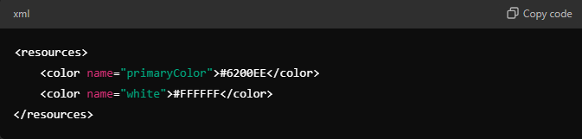
- strings.xml: Define string resources for the app.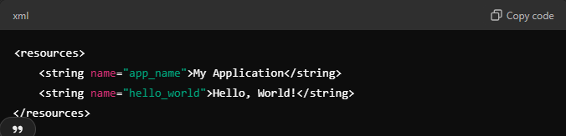
- themes.xml: Define application-wide themes.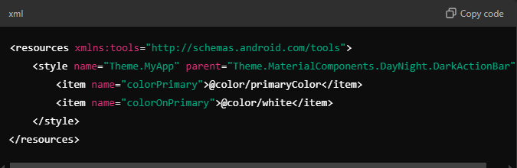

This is INTENT
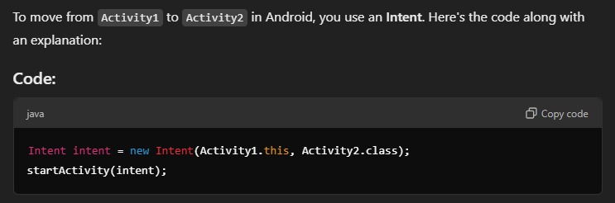
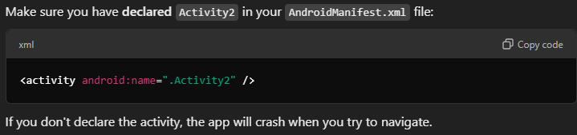

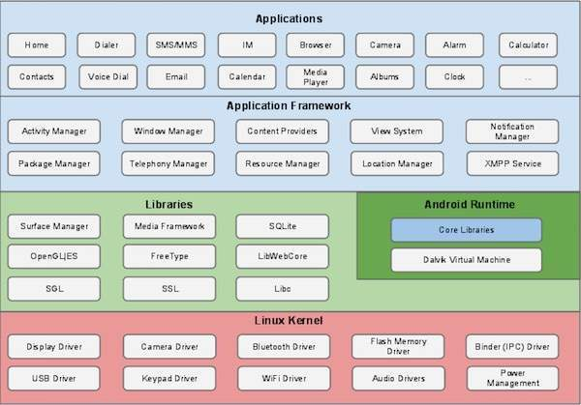
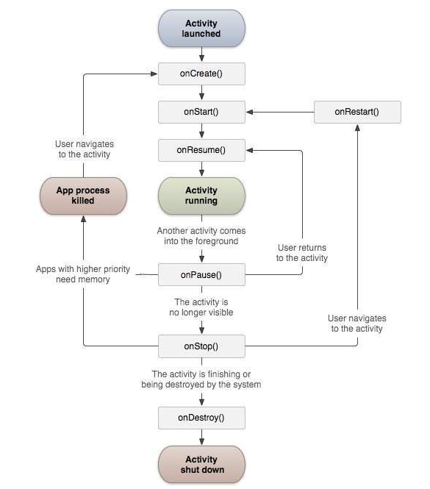
Activity

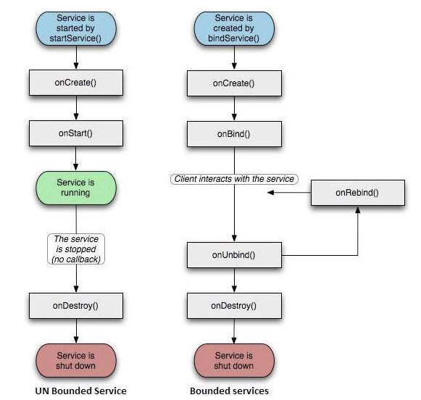
Services

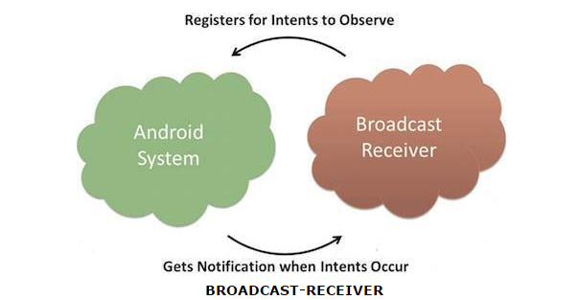
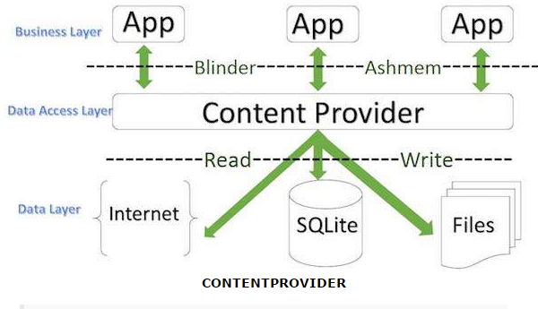

Inheritance
When we talk about inheritance, the most commonly used keyword would be extends and implements.
Example:
- public class Animal{ }
- public class Mammal extends Animal{ }
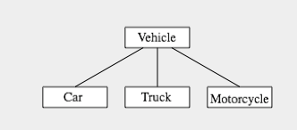
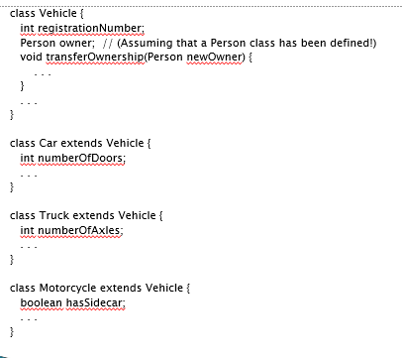

Polymorphism
Polymorphism in Java has two types:
  - Compile time polymorphism (static binding)
  - Runtime polymorphism (dynamic binding).
  - Method overloading is an example of static polymorphism.
  - while method overriding is an example of dynamic polymorphism.
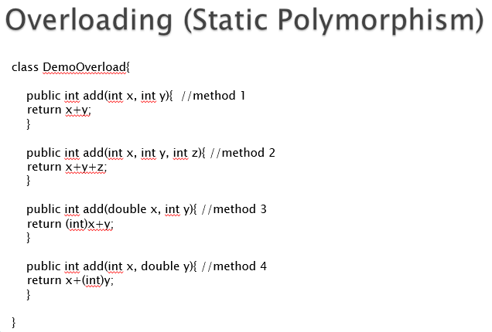
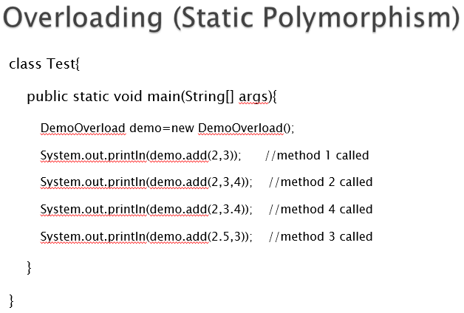

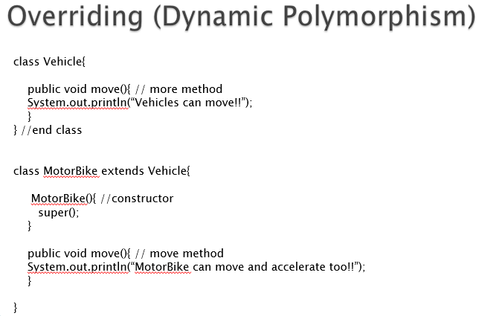
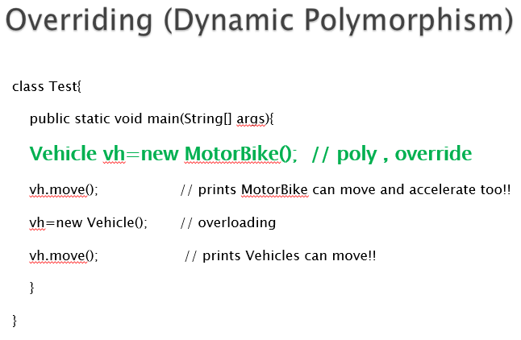

As the method to call is determined at runtime, this is called dynamic binding or late binding.

Association

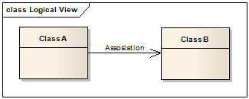
Weak Association
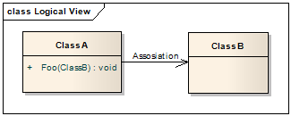
Strong Association
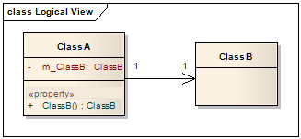
Example:
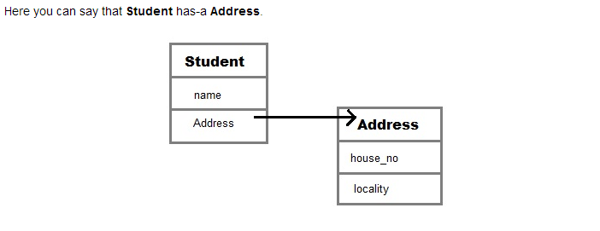

Aggregation (HAS-A)

A has a relation with B
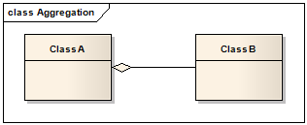

  - it provides us a code reusability

Aggregation VS Association
  - The association link can replace the aggregation link in every situation.

  - while aggregation cannot replace association in situations were there is only a ‘weak link’ between the classes,
  - i.e. ClassA has method/s that contain parameter of ClassB but ClassA doesn’t hold reference to ClassB instance.
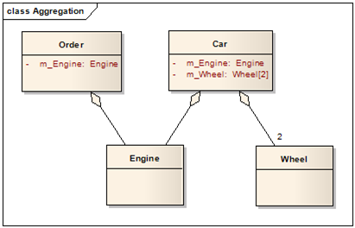

Composition
- Composition is restricted form of Aggregation.
- For example a class Car cannot exist without Engine.

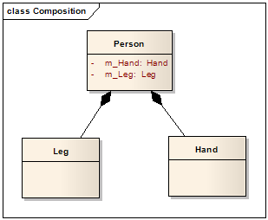

When to use Inheritance and Aggregation
  - When you need to use property and behavior of a class without modifying it inside your class. In such case Aggregation is a better option.
  - Whereas when you need to use and modify property and behavior of a class inside your class, its best to use Inheritance.

